# 2015 Dodge Dynasty Champion - Jeremiah Yugulis

Congratulations to Jeremiah Yugulis for winning his first Dodge Dynasty League Championship! Capping off a year where he clinched a playoff berth in an exciting final week of the regular season, Jeremiah endured a slew of injuries to key contributors like Justin Forsett (broken arm), Dion Lewis (torn ACL), and Davante Adams (fossilized hands), and even overcame a lost season by his team's namesake to rise to the top. Despite the absence of Luck, Jeremiah still had all the luck he needed to get past an up-and-coming Pooper Cooper squad with an unlikely Round One comeback win, only to thrust the ship into Ludicrous Speed and score a record 293 total points over his final two games. JM received gargantuan performances from playoff Co-MVPs Russell Wilson and David Johnson, as well as huge contributions from Dodge Dynasty MVP Julio Jones, Brandin Cooks, Mike Evans, and even the Arizona Cardinals defense. (31 points in Week 16 by a defense??!). He cruised past the #1 overall seed 11-2 Meatsian Dynasty in Round Two, and was on the winning side of the highest scoring dynasty playoff game ever, outlasting an extraordinary effort by Dave Nickelsen's squad to win the championship 140-116. Congratulations Jeremiah, well-deserved!

# 2015 Dodge Dynasty Awards

**Dodge Dynasty MVP**

* Julio Jones - Jeremiah. (Runners-up: Antonio Brown - Shannon, Adrian Peterson - Dave, Brandon Marshall - Meat)

**Playoff MVP**

* Russell Wilson and David Johnson - Jeremiah

**Pickup of the Year**

* Russell Wilson - Jeremiah. (Runners-up: DeAngelo Williams - Brian, Doug Baldwin - Jen, Blake Bortles - Dave)

**Sleeper of the Year (i.e. played on the team that drafted them)**

* Devonta Freeman - Dave. (Runners-up: Larry Fitzgerald - Joe, Carson Palmer - Shannon, David Johnson - Jeremiah)

**Bust of the Year (non-injury)**

* C.J. Anderson - Steve. (Runners-up: Eddie Lacy - Brian, DeMarco Murray - George, Alfred Morris - Jen)

**Comeback Player of the Year**

* Adrian Peterson - Dave. (Runners-up: Doug Martin - Meat, Carson Palmer – Shannon, Larry Fitzgerald - Joe)

**Dodge Dynasty Coach/GM of the Year**

* Joe Hayek. (Runners-up: Jeremiah Yugulis, Matt Robson, Dave Nickelsen)

**Tennessee Titan of the Year**

* No one.

**Most Heartbreaking Loss at The Hands of Their Spouse in Week 13**

* Jeremiah over Brian 106-73. (Runner-Up: Jen over George 96-86)

**Most Valuable Pohlmann**

* Jeff Pohlmann. (Runners-Up: Lisa Pohlmann, Andrew Pohlmann, Brady Pohlmann, Charcandrick Pohlmann)

**Most Cleveland Browns Moment of the Year**

* Having game-winning FG attempt returned for game-winning TD vs Ravens (Runners-up: Losing on untimed down FG after offsides penalty vs Chargers, giving Dwayne Bowe $9 million, announcing Miss Colombia as winner of Miss Universe pageant)

**Most Adorable Niece**

* My niece Samantha Dougherty

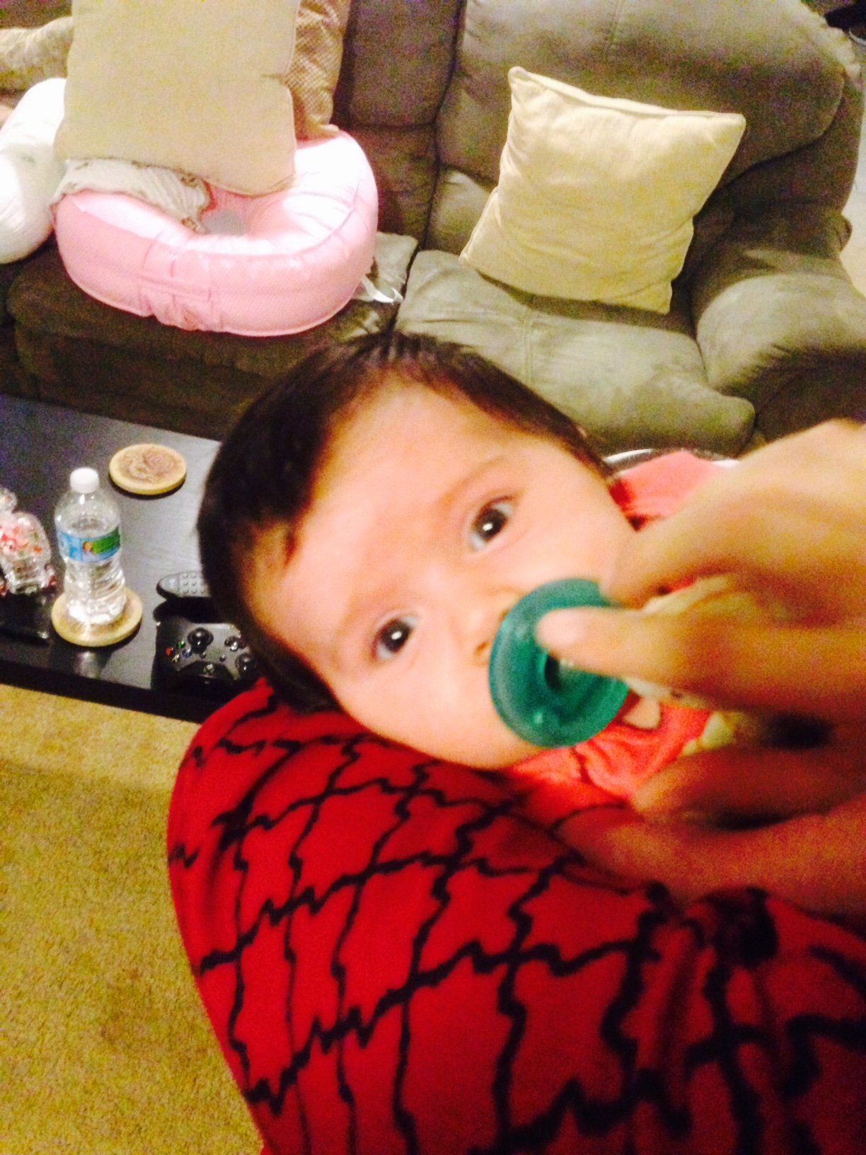

**Least Adorable Niece**

* Matt Robson

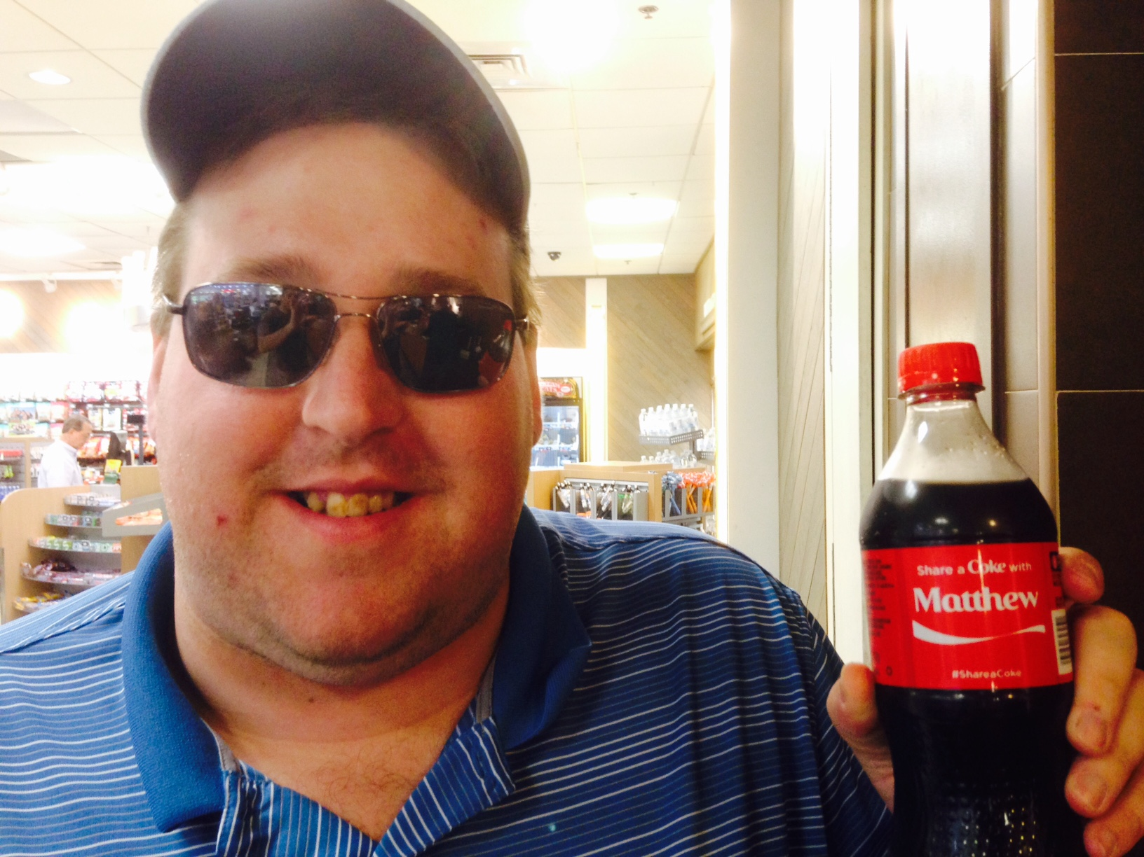

**Most Likely to Miss Next Year's Dodge Dynasty Draft**

* Shannon Anderson

**Most Likely to Run into Shannon at a Northeast Ohio Minor League/Semi-Professional Sporting Event**

* George Hayek

**Most Impressionable Toddler Subjected to a Lifetime of Local Professional Sports Disappointments**

* Soren Nickelsen

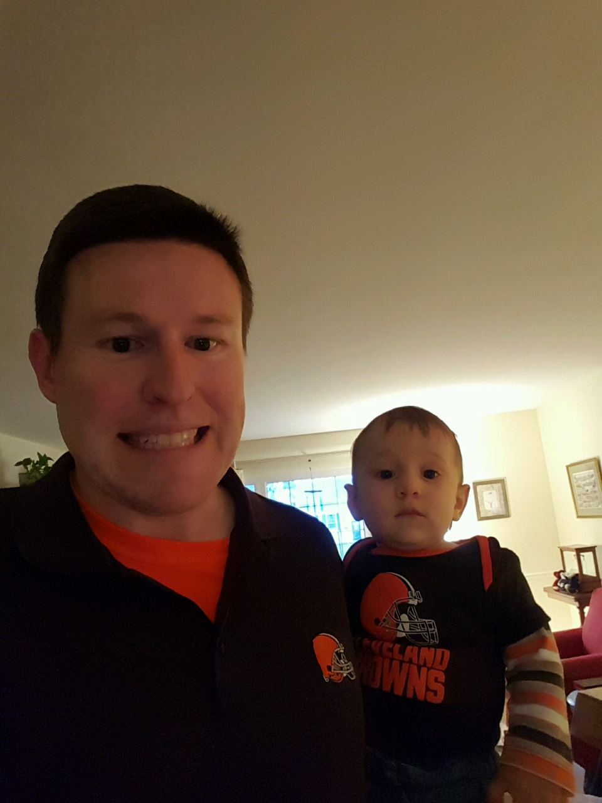

**Gurliest Girl**

* Jen Hayek (Runner-up: Brian Kenderes)

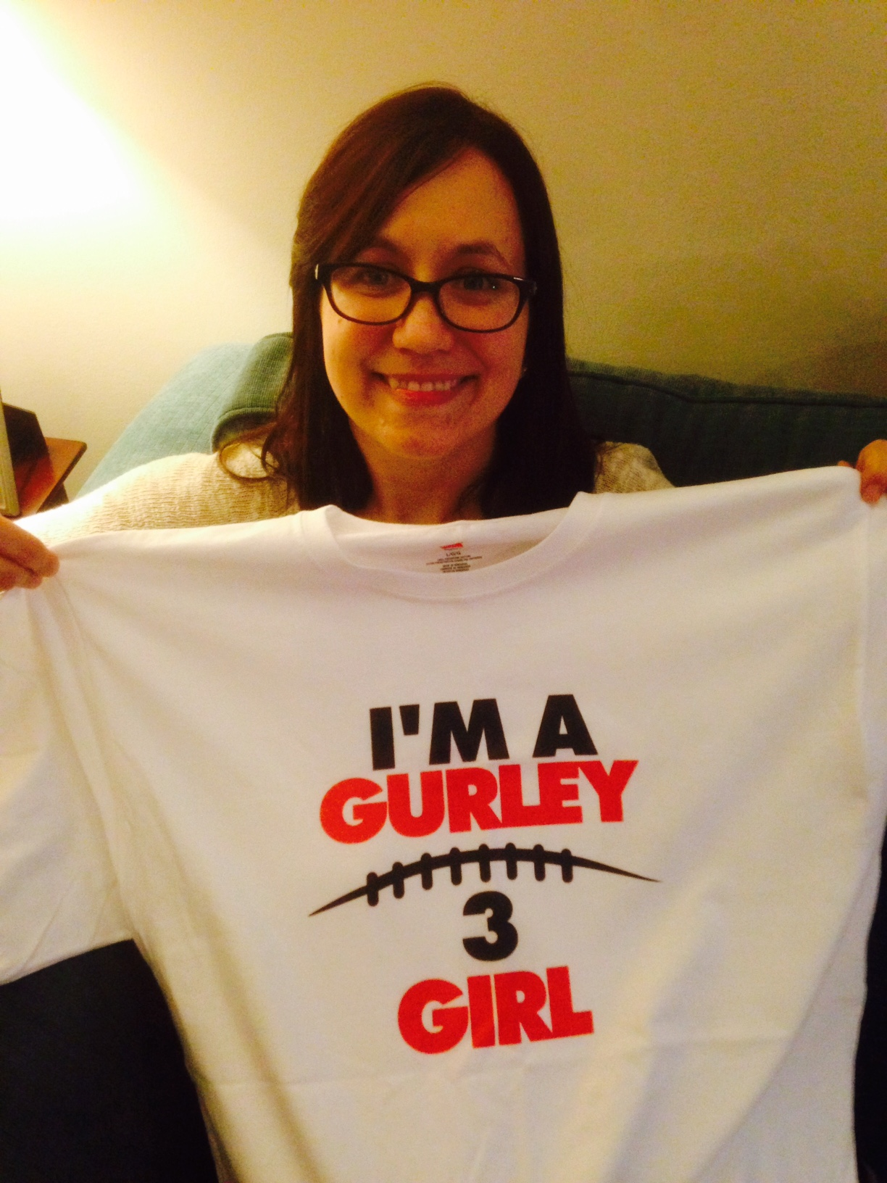

# Additional Awards

**Rookie of the Year**

* Todd Gurley - Jen. (Runners-up: Amari Cooper - Joe, David Johnson - Jeremiah Yugulis, T.J. Yeldon - Brian)

**Most Likely to Complain That Brandon Marshall Is Awesome and Should’ve Gotten an Award**

* Meat.

**Brandon Marshall Award, for Being the NFL’s Best Brandon Marshall**

* Brandon Marshall - Inside Linebacker for the Denver Broncos. (Runner-up: Brandon Marshall - Meat)

**(Per Dave) Most Improved Jaguars QB**

* Tie: Blake Bortles - Dave, and Blaine Gabbert - No One Ever.

**(Per Dave) Bryant Gumbel Award for Racial Diversity**

* Willie Snead - Meat. (Runner-up: Jimmy Graham - Pohlmann)

**Nick Foles Award, for Flukiest Season/Great Fantasy Stats by Nauseating Real Life Player**

* Tie: Ted Ginn Jr. - Brian, and Blake Bortles - Dave. (Runner-up: Ryan Fitzpatrick - Shannon)

**Willis McGahee Award, for Guy Who I Am Convinced Should Be Finished but Proved Me Wrong**

* Darren McFadden - Jeremiah. (Runner-up: Chris Johnson - Steve)

**Poorly Articulated Award for A Should-Be Great, but Predictably Injury-Prone, Player Who Is Always Hurt or Rumored to Be Hurt and You Know He Would Just Dominate If He Could Stay Healthy for More Than a Few Weeks but Rarely Does (perhaps The Fred Taylor Award?)**

* Alshon Jeffery - Shannon. (Runners-up: Arian Foster - Pohlmann, LeSean McCoy - Dave)

**(Per Meat) Blue Balls Award, for Teasing Us All Year but Never Really Erupting**

* Demaryius Thomas - Steve. (Runners-up: Randall Cobb - George, Jordan Matthews - Shannon)

**Silliest Goose**

* Steve Miller. (Runner-up: Steve Miller’s Cat Curtis)

# 2015 Adjusted Total Points (for Non-Playoff Draft Order)

|  |  |  |  |  |  |  |  |
| --- | --- | --- | --- | --- | --- | --- | --- |
| Throw out High Score, Low Score, and Week 13 | | | |  |  |  |  |
|  |  |  |  |  | **(Jen and Pohlmann will be drafting divisions)** | | |
|  | **Total Points** | **High Week** | **High Score** | **Low Week** | **Low Score** | **Week 13 Score** | **Adjusted Total Points** |
| Breaking Badly | 1019 | Week 9 | 101 | Week 11 | 48 | **87** | **783** |
| Gurley Girl | 1048 | Week 7 | 103 | Week 5 | 59 | **96** | **790** |
| We're Not Detroit | 1065 | Week 3 | 108 | Week 11 | 52 | 86 | **819** |
| World Plague | 1149 | Week 9 | 130 | Week 2 | 40 | 73 | **906** |
|  |  |  |  |  |  |  |  |

At the 2016 draft I’ll discuss a change to this formula to further credit people for playing hard down the stretch, along with some other items TBD (i.e. hidden league settings, late stat corrections, trades, 2 pt return scoring).